### **Multiple-Choice Questions (MCQs):**

**JavaScript Fundamentals:**

What does the typeof operator return when used with typeof 42?

A) number

B) string

C) object

D) undefined

Which keyword is used to declare a variable in JavaScript?

A) var

B) int

C) let

D) const

What is the result of "5" + 2 in JavaScript?

A) "52"

B) 7

C) "7"

D) Error

How do you comment a single line in JavaScript?

A) // This is a comment

B) <!-- This is a comment -->

C) /* This is a comment */

D) # This is a comment

Which function is used to display a message in a popup box in JavaScript?

A) alert()

B) confirm()

C) prompt()

D) console.log()

What will be the output of console.log(3 === '3') in JavaScript?

A) true

B) false

C) undefined

D) Error

How do you declare a function in JavaScript?

A) function myFunction() {}

B) def myFunction():

C) void myFunction() {}

D) function = myFunction() {}

What is the correct way to include an external JavaScript file named script.js in an HTML document?

A) <script href="script.js"></script>

B) <script src="script.js"></script>

C) <script include="script.js"></script>

D) <script import="script.js"></script>

Which loop is used for iterating over the properties of an object in JavaScript?

A) for loop

B) while loop

C) do-while loop

D) for...in loop

What is the result of NaN === NaN in JavaScript?

A) true

B) false

C) undefined

D) Error

**Bootstrap Basics:**

Which CSS framework is Bootstrap built on top of?

A) Sass

B) Less

C) CSS

D) None of the above

Which class is used to create a responsive navigation bar in Bootstrap?

A) .navbar-fixed

B) .navbar-responsive

C) .navbar-expand

D) .navbar

How do you create a grid layout in Bootstrap?

A) Using <table> tags

B) Using <div> tags with custom CSS

C) Using .container and .row classes

D) Using inline CSS styles

Which class is used to create a responsive image in Bootstrap?

A) .img-fluid

B) .responsive-img

C) .img-responsive

D) .fluid-image

How do you create a button in Bootstrap with rounded corners?

A) .btn

B) .btn-primary

C) .btn-rounded

D) .btn-rounded-corners

Which grid class is used to create a full-width column in Bootstrap?

A) .col-md-12

B) .col-sm-12

C) .col-lg-12

D) .col-12

How do you create a modal dialog in Bootstrap?

A) Using <dialog> tags

B) Using <div> tags with custom CSS

C) Using .modal and .modal-dialog classes

D) Using JavaScript alert() function

Which class is used to create a dropdown menu in Bootstrap?

A) .dropdown-toggle

B) .dropdown-menu

C) .dropdown

D) .drop-menu

How do you create a responsive table in Bootstrap?

A) Using <table> tags with custom CSS

B) Using .table and .table-responsive classes

C) Using <div> tags with inline styles

D) Using JavaScript to dynamically adjust table size

Which class is used to create a carousel (image slider) in Bootstrap?

A) .carousel-item

B) .carousel-slide

C) .slider

D) .carousel

Answer: D) .carousel

### **Exercise Questions:**

Create a simple JavaScript program that prompts the user to enter two numbers, then displays their sum in an alert box.

**Program:**

<!DOCTYPE html>

<html>

<body>

<h2>JavaScript Arithmetic</h2>

<p>Sum of 2 numbers.</p>

<script>

num1 = prompt("Enter the first number:");

num2 = prompt("Enter the second number:");

sum = parseFloat(num1) + parseFloat(num2);

alert("The sum is: " + sum);

</script>

</body>

</html>

**Output:**

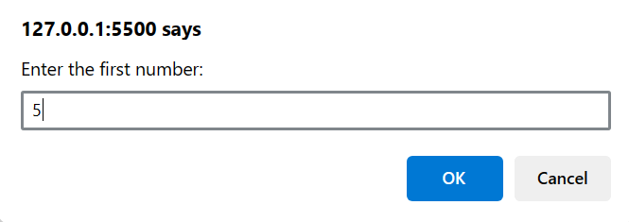

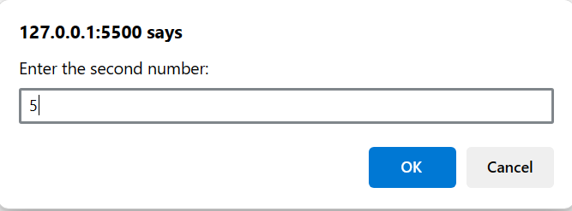

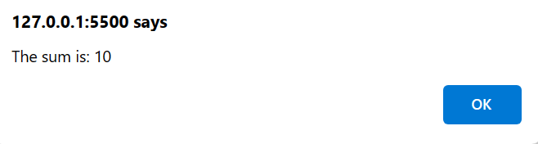

Develop a JavaScript function that takes a Celsius temperature as input and converts it to Fahrenheit, then logs the result to the console.

**Program:**

<!DOCTYPE html>

<html lang="en">

<head>

  <meta charset="UTF-8">

  <meta name="viewport" content="width=device-width, initial-scale=1.0">

  <title>Celsius to Fahrenheit Converter</title>

</head>

<body>

  <h1>Celsius to Fahrenheit Converter</h1>

  <p>Enter a temperature in Celsius:</p>

  <input type="number" id="celsiusInput" placeholder="Celsius">

  <button onclick="convertCelsiusToFahrenheit()">Convert</button>

  <p id="fahrenheitOutput"></p>

  <script>

    function celsiusToFahrenheit(celsius) {

  const fahrenheit = (celsius * 9 / 5) + 32;

  return fahrenheit.toFixed(1);

}

function convertCelsiusToFahrenheit() {

  const celsiusInput = document.getElementById("celsiusInput");

  const celsiusValue = parseFloat(celsiusInput.value);

  if (isNaN(celsiusValue)) {

    alert("Please enter a valid number.");

    return;

  }

  const fahrenheit = celsiusToFahrenheit(celsiusValue);

  const outputElement = document.getElementById("fahrenheitOutput");

  outputElement.textContent = `${celsiusValue}°C is equal to ${fahrenheit}°F`;

}

  </script>

</body>

</html>

**Output:**

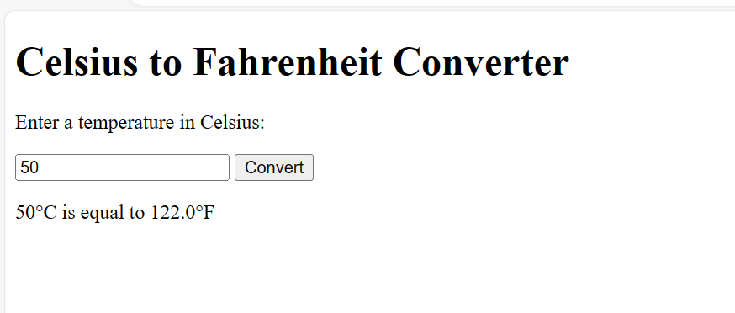

Build a basic Bootstrap webpage with a responsive navigation bar (navbar), a Jumbotron (jumbotron), and a grid layout (container and row).

**Program:**

<!DOCTYPE html>

<html lang="en">

<head>

  <meta charset="UTF-8">

  <meta name="viewport" content="width=device-width, initial-scale=1.0">

  <title>Basic Bootstrap Page</title>

  <link href="https://cdn.jsdelivr.net/npm/bootstrap@5.1.3/dist/css/bootstrap.min.css" rel="stylesheet" integrity="sha384-1BmE4kWBq78iYhFldvKuhfTAU6auU8tT94WrHftjDbrCEXSU1oBoqyl2QvZ6jIW3" crossorigin="anonymous">

<style>

  .jumbotron{

    text-align: center;

    color: black;

    background-color: lightslategray;

  }

</style>

</head>

<body>

  <nav class="navbar navbar-expand-sm bg-light">

    <div class="container">

      <a class="navbar-brand" href="#">My Website</a>

      <button class="navbar-toggler" type="button" data-bs-toggle="collapse" data-bs-target="#navbarNav" aria-controls="navbarNav" aria-expanded="false" aria-label="Toggle navigation">

        <span class="navbar-toggler-icon"></span>

      </button>

      <div class="collapse navbar-collapse" id="navbarNav">

        <ul class="navbar-nav ms-auto">

          <li class="nav-item">

            <a class="nav-link active" aria-current="page" href="#">Home</a>

          </li>

          <li class="nav-item">

            <a class="nav-link" href="#">About</a>

          </li>

          <li class="nav-item">

            <a class="nav-link" href="#">Contact</a>

          </li>

        </ul>

      </div>

    </div>

  </nav>

  <div class="jumbotron">

    <div class="container">

      <h1 class="display-4">Welcome to my<br><strong>NEW WEBSITE</strong>!</h1>

      <p class="lead">This is a basic Bootstrap website example.</p>

      <hr class="my-4">

      <p>It includes a responsive navbar, a Jumbotron, and a grid layout.</p>

      <a class="btn btn-primary btn-lg" href="#" role="button">Learn More</a><br><br>

    </div>

  </div>

  <div class="container">

    <div class="row">

      <div class="col-md-4">

        <h3>Section 1</h3>

        <p>This is some content in the first column.</p>

      </div>

      <div class="col-md-4">

        <h3>Section 2</h3>

        <p>This is some content in the second column.</p>

      </div>

      <div class="col-md-4">

        <h3>Section 3</h3>

        <p>This is some content in the third column.</p>

      </div>

    </div>

  </div>

  <script src="https://cdn.jsdelivr.net/npm/bootstrap@5.1.3/dist/js/bootstrap.bundle.min.js" integrity="sha384-ka7Sk0Gln4gmtz2MlQnikT1wXgYsOg+OMhuP+IlRH9sENBO0LRn5q+8nbTov4+1p" crossorigin="anonymous"></script>

</body>

</html>

**Output:**

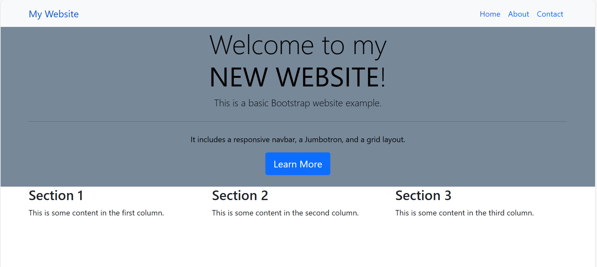

Implement a Bootstrap form with text input fields and a submit button, then use JavaScript to display the entered values in an alert box upon submission.

**Program:**

<!DOCTYPE html>

<html lang="en">

<head>

    <meta charset="UTF-8">

    <meta name="viewport" content="width=device-width, initial-scale=1.0">

    <meta http-equiv="X-UA-Compatible" content="IE=edge">

    <title>Bootstrap Form</title>

    <link href="https://cdn.jsdelivr.net/npm/bootstrap@5.4.3/dist/css/bootstrap.min.css" rel="stylesheet">

</head>

<body>

    <div class="container">

        <h2>Login form</h2>

        <form id="myForm">

          <div class="mb-3">

            <label for="firstName" class="form-label">First Name</label>

            <input type="text" class="form-control" id="firstName" name="firstName" required><br><br>

          </div>

          <div class="mb-3">

            <label for="lastName" class="form-label">Last Name</label>

            <input type="text" class="form-control" id="lastName" name="lastName" required><br><br>

          </div>

          <button type="submit" class="btn btn-primary">Submit</button>

        </form>

      </div>

      <!-- Bootstrap JS -->

      <script src="https://cdn.jsdelivr.net/npm/bootstrap@5.4.3/dist/js/bootstrap.bundle.min.js"></script>

      <script>

        document.getElementById("myForm").addEventListener("submit", function(event)

        {

          event.preventDefault();

          var firstName = document.getElementById("firstName").value;

          var lastName = document.getElementById("lastName").value;

          var message = "First Name: " + firstName + "\nLast Name: " + lastName;

          alert(message);

        });

      </script>

</body>

</html>

**Output:**

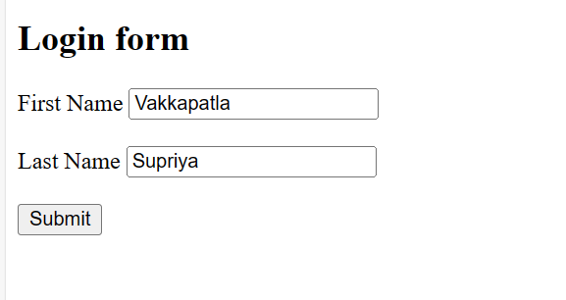

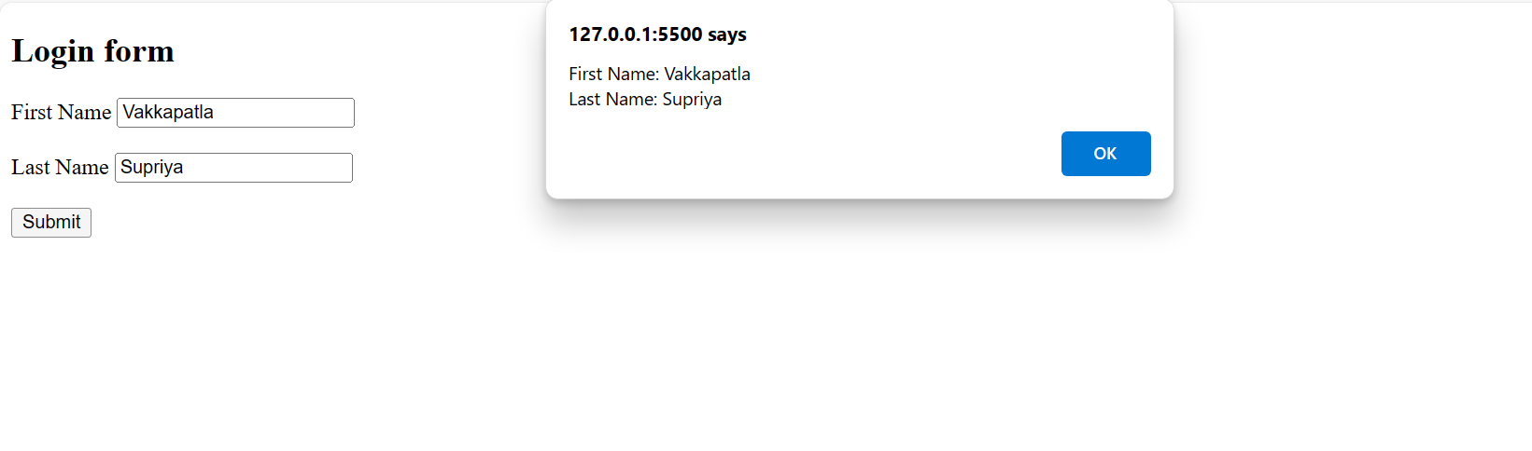

Create a Bootstrap modal dialog that opens when a button is clicked, displaying a message or additional content.

**Program:**

<!DOCTYPE html>

<html lang="en">

<head>

    <meta charset="UTF-8">

    <meta name="viewport" content="width=device-width, initial-scale=1.0">

    <link rel="stylesheet" href="https://maxcdn.bootstrapcdn.com/bootstrap/3.4.1/css/bootstrap.min.css">

    <script src="https://ajax.googleapis.com/ajax/libs/jquery/3.7.1/jquery.min.js"></script>

    <script src="https://maxcdn.bootstrapcdn.com/bootstrap/3.4.1/js/bootstrap.min.js"></script>

    <title>Bootstrap Modal Example</title>

</head>

<body>

    <div class="container">

        <h2>Bootstrap Modal Example</h2>

        <!-- Trigger the modal with a button -->

        <button type="button" class="btn btn-info btn-lg" data-toggle="modal" data-target="#myModal">Open Modal</button>

        <!-- Modal -->

        <div class="modal fade" id="myModal" role="dialog">

          <div class="modal-dialog">

            <!-- Modal content-->

            <div class="modal-content">

              <div class="modal-header">

                <button type="button" class="close" data-dismiss="modal">&times;</button>

                <h4 class="modal-title">Modal Header</h4>

              </div>

              <div class="modal-body">

                <p>Some text in the modal.</p>

              </div>

              <div class="modal-footer">

                <button type="button" class="btn btn-default" data-dismiss="modal">Close</button>

              </div>

            </div>

          </div>

        </div>

      </div>

</body>

</html>

**Output:**

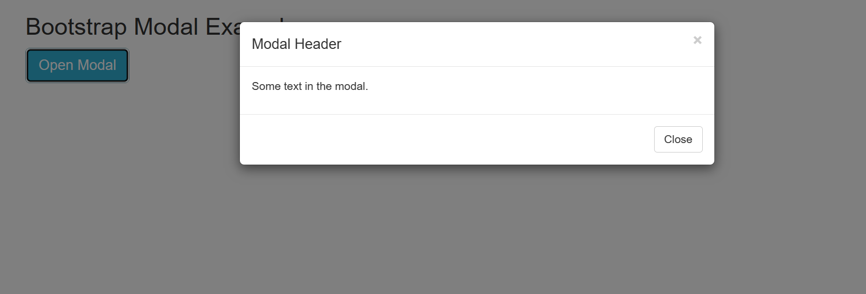

Design a Bootstrap card layout (card) with multiple cards displaying images and text content.

**Program:**

<!DOCTYPE html>

<html lang="en">

<head>

    <meta charset="UTF-8">

    <meta name="viewport" content="width=device-width, initial-scale=1.0">

    <link href="https://cdn.jsdelivr.net/npm/bootstrap@5.3.3/dist/css/bootstrap.min.css" rel="stylesheet">

    <script src="https://cdn.jsdelivr.net/npm/bootstrap@5.3.3/dist/js/bootstrap.bundle.min.js"></script>

    <title>Bootstrap card layout </title>

</head>

<body>

    <div class="container mt-3">

        <h2>Multiple Card Layout Images</h2>

        <div class="row">

        <div class="col-md-6">

        <div class="card">

          <img class="card-img-top" src="https://media.glassdoor.com/l/ac/c9/de/81/greemus-software-technologies.jpg" alt="Card image" style="width:100%">

          <div class="card-body">

            <h4 class="card-title">Greemus Software Technologies</h4>

            <p class="card-text">Greemus Technologies is a customer oriented company offering Mobile applications, Software Development, Web Development.</p>

            <a href="#" class="btn btn-primary">See Company Profile</a>

          </div>

        </div>

        </div>

        <br>

        <div class="col-md-6">

        <div class="card">

            <img class="card-img-top" src="https://media.assettype.com/fortuneindia/2019-01/406d200f-8bf8-4f06-8d5d-40665562151b/TCS_Campus_9_copy.JPG?w=1200&h=797" alt="Card image" style="width:100%">

            <div class="card-body">

              <h4 class="card-title">Tata Consultancy Services</h4>

              <p class="card-text">Tata Consultancy Services is an IT services, consulting, and business solutions organization that has been partnering with many of the world's largest businesses in their transformation journeys for over 50 years.</p>

              <a href="#" class="btn btn-primary">See Company Profile</a>

            </div>

          </div>

        </div>

        </div>

</body>

</html>

**Output:**



Develop a Bootstrap dropdown menu (dropdown) with multiple menu items that link to different sections or pages.

**Program:**

<!DOCTYPE html>

<html lang="en">

<head>

    <meta charset="UTF-8">

    <meta name="viewport" content="width=device-width, initial-scale=1.0">

    <link href="https://cdn.jsdelivr.net/npm/bootstrap@5.3.3/dist/css/bootstrap.min.css" rel="stylesheet">

    <script src="https://cdn.jsdelivr.net/npm/bootstrap@5.3.3/dist/js/bootstrap.bundle.min.js"></script>

    <title>Bootstrap dropdown menu</title>

</head>

<body>

    <div class="container mt-3">

        <h2>Dropdowns</h2>

        <p>Dropdown menu that links to different pages</p>

        <div class="dropdown">

          <button type="button" class="btn btn-primary dropdown-toggle" data-bs-toggle="dropdown">Dropdown button</button>

          <ul class="dropdown-menu">

            <li><a class="dropdown-item" href="https://luminous-kringle-45aeb8.netlify.app/">Home</a></li>

            <li><a class="dropdown-item" href="https://luminous-kringle-45aeb8.netlify.app/#about-section">About</a></li>

            <li><a class="dropdown-item" href="https://luminous-kringle-45aeb8.netlify.app/#services-section">Services</a></li>

            <li><a class="dropdown-item" href="https://luminous-kringle-45aeb8.netlify.app/#contact-section">Contact</a></li>

        </ul>

        </div>

      </div>

</body>

</html>

**Output:**

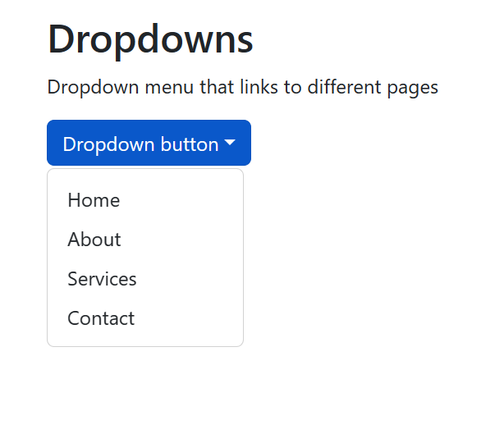

**Home page:**



Build a responsive table using Bootstrap (table and table-responsive) to display tabular data.

**Program:**

<!DOCTYPE html>

<html lang="en">

<head>

  <title>Bootstrap Responsive Table</title>

  <meta charset="utf-8">

  <meta name="viewport" content="width=device-width, initial-scale=1">

  <link href="https://cdn.jsdelivr.net/npm/bootstrap@5.3.3/dist/css/bootstrap.min.css" rel="stylesheet">

  <script src="https://cdn.jsdelivr.net/npm/bootstrap@5.3.3/dist/js/bootstrap.bundle.min.js"></script>

</head>

<body>

<div class="container mt-3">

  <h2>Employee Table</h2>

  <p>Employee details will be displayed below:</p>

  <table class="table table-bordered">

    <thead>

      <tr>

        <th>#</th>

        <th>Firstname</th>

        <th>Lastname</th>

        <th>Email</th>

      </tr>

    </thead>

    <tbody>

      <tr>

        <td>1</td>

        <td>John</td>

        <td>Doe</td>

        <td>john@tcs.com</td>

      </tr>

      <tr>

        <td>2</td>

        <td>Mary</td>

        <td>Moe</td>

        <td>mary@tcs.com</td>

      </tr>

      <tr>

        <td>3</td>

        <td>Sai</td>

        <td>Dooley</td>

        <td>sai@tcs.com</td>

      </tr>

    </tbody>

  </table>

</div>

</body>

</html>

**Output:**

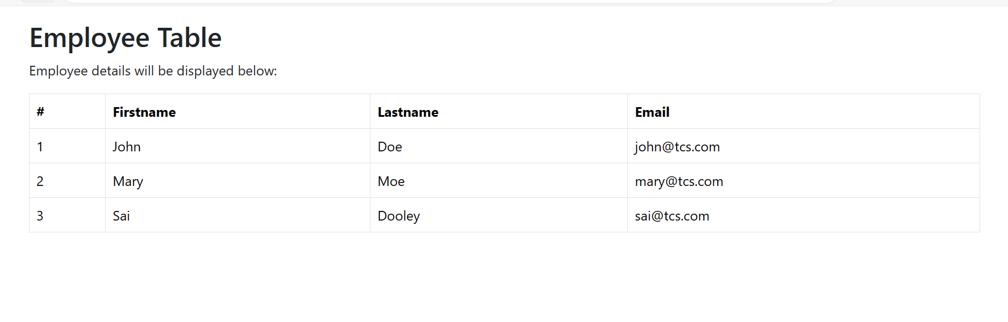

Design a Bootstrap carousel (carousel) with multiple slides/images that automatically cycle through.

**Program:**

<!DOCTYPE html>

<html lang="en">

<head>

    <meta charset="UTF-8">

    <meta name="viewport" content="width=device-width, initial-scale=1.0">

    <link href="https://cdn.jsdelivr.net/npm/bootstrap@5.3.3/dist/css/bootstrap.min.css" rel="stylesheet">

    <script src="https://cdn.jsdelivr.net/npm/bootstrap@5.3.3/dist/js/bootstrap.bundle.min.js"></script>

    <title>Bootstrap carousel</title>

</head>

<body>

    <!-- Carousel -->

<div id="demo" class="carousel slide" data-bs-ride="carousel">

    <!-- Indicators/dots -->

    <div class="carousel-indicators">

      <button type="button" data-bs-target="#demo" data-bs-slide-to="0" class="active"></button>

      <button type="button" data-bs-target="#demo" data-bs-slide-to="1"></button>

      <button type="button" data-bs-target="#demo" data-bs-slide-to="2"></button>

    </div>

    <!-- The slideshow/carousel -->

    <div class="carousel-inner">

      <div class="carousel-item active">

        <img src="https://d1csarkz8obe9u.cloudfront.net/posterpreviews/welcome-greeting-design-template-e8784b1452945e3c38bfe844ea3a8b86_screen.jpg?ts=1645235492" alt="welcome" class="d-block" style="width:100%" height="20%">

      </div>

      <div class="carousel-item">

        <img src="https://media.glassdoor.com/l/05/3f/eb/4e/greemus-software-technologies.jpg" alt="Company" class="d-block" style="width:100%" height="20%">

      </div>

      <div class="carousel-item">

        <img src="https://www.greemus.com/assets/images/new%20images/about02.jpg" alt="Team" class="d-block" style="width:100%" height="20%">

      </div>

    </div>

    <!-- Left and right controls/icons -->

    <button class="carousel-control-prev" type="button" data-bs-target="#demo" data-bs-slide="prev">

      <span class="carousel-control-prev-icon"></span>

    </button>

    <button class="carousel-control-next" type="button" data-bs-target="#demo" data-bs-slide="next">

      <span class="carousel-control-next-icon"></span>

    </button>

  </div>

  <div class="container-fluid mt-3">

    <h3>Carousel Example</h3>

    <p>The following example shows how to create a basic carousel with indicators and controls.</p>

  </div>

</body>

</html>

**Output:**

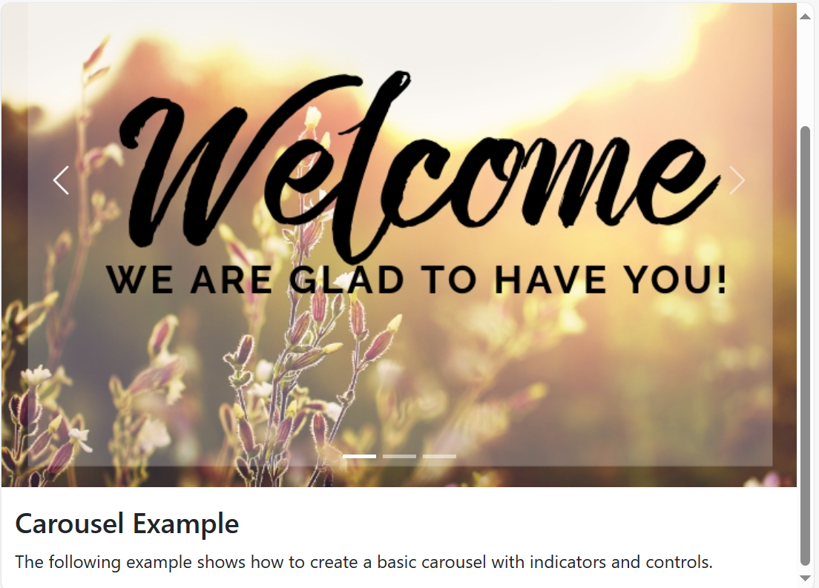

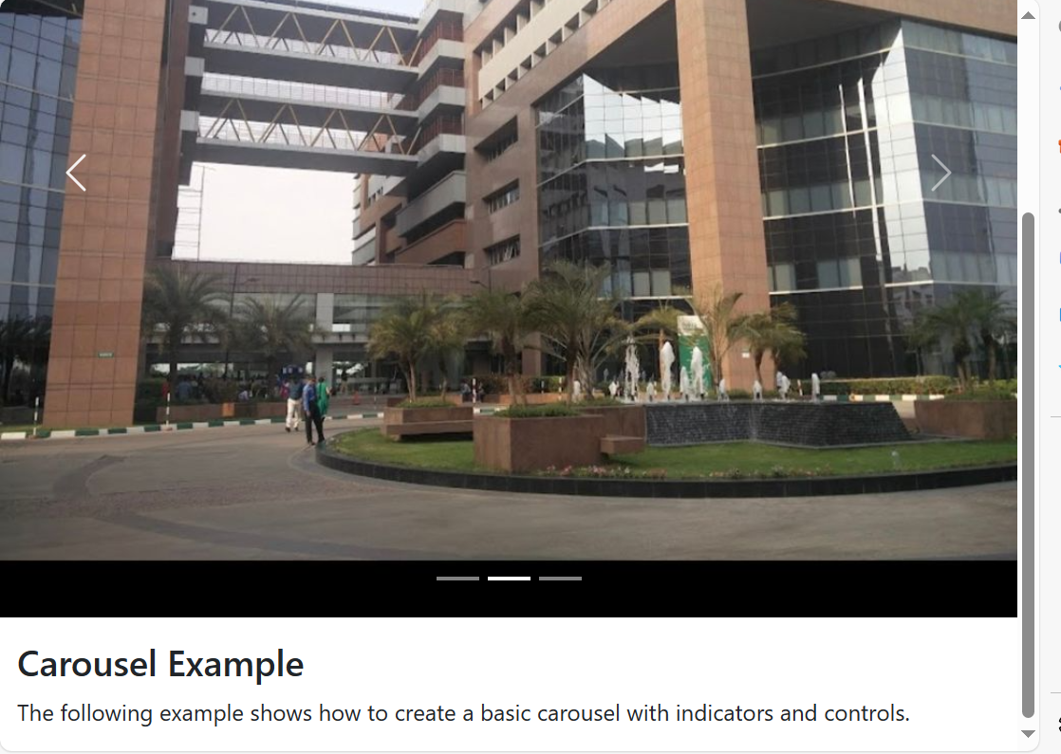

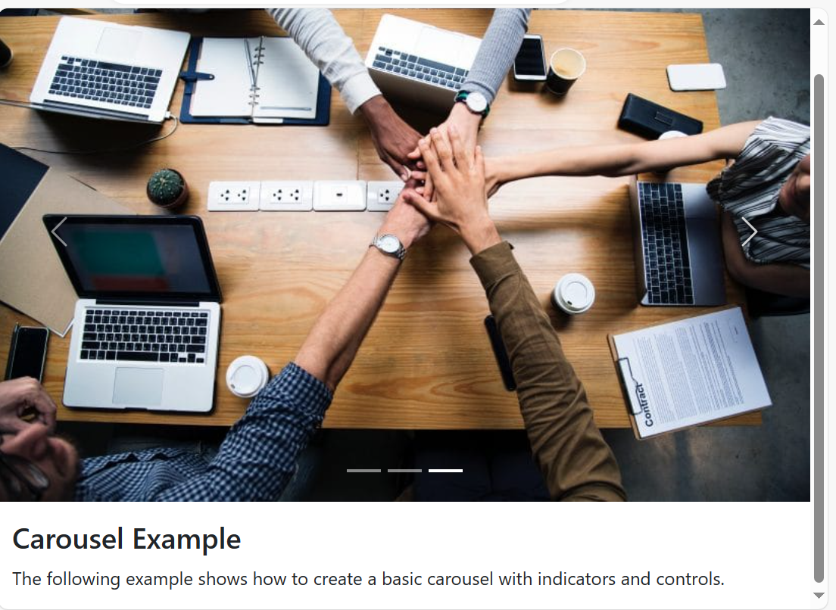

Combine JavaScript and Bootstrap to create a dynamic webpage that updates content based on user interactions (e.g., show/hide elements, change styles).

**Program:**

<!DOCTYPE html>

<html lang="en">

<head>

  <meta charset="UTF-8">

  <meta name="viewport" content="width=device-width, initial-scale=1.0">

  <title>Dynamic Webpage</title>

  <link href="https://cdn.jsdelivr.net/npm/bootstrap@5.1.3/dist/css/bootstrap.min.css" rel="stylesheet" integrity="sha384-1BmE4kWBq78iYhFldvKuhfTAU6auU8tT94WrHftjDbrCEXSU1oBoqyl2QvZ6jIW3" crossorigin="anonymous">

</head>

<body>

  <div class="container">

    <h1>Dynamic Content</h1>

    <button type="button" class="btn btn-primary" id="toggleButton">Show Details</button>

    <p id="details" class="d-none">This is some hidden content that will be shown/hidden on button click.</p>

    <div class="row">

      <div class="col-md-6" id="colorBox">

        <h2>Change Color</h2>

        <select class="form-select" id="colorSelect">

          <option value="primary">Blue</option>

          <option value="success">Green</option>

          <option value="danger">Red</option>

        </select>

      </div>

    </div>

  </div>

  <script>

    const toggleButton = document.getElementById("toggleButton");

const detailsElement = document.getElementById("details");

const colorSelect = document.getElementById("colorSelect");

const colorBox = document.getElementById("colorBox");

// Toggle details content on button click

toggleButton.addEventListener("click", function() {

  detailsElement.classList.toggle("d-none");  // Use Bootstrap's d-none class

  if (detailsElement.classList.contains("d-none")) {

    toggleButton.textContent = "Show Details";

  } else {

    toggleButton.textContent = "Hide Details";

  }

});

// Change color box background on select change

colorSelect.addEventListener("change", function() {

  const selectedColor = colorSelect.value;

  colorBox.classList.remove("bg-primary", "bg-success", "bg-danger"); // Remove previous colors

  colorBox.classList.add(`bg-${selectedColor}`);  // Add new color class based on selection

});

  </script>

  <script src="https://cdn.jsdelivr.net/npm/bootstrap@5.1.3/dist/js/bootstrap.bundle.min.js" integrity="sha384-ka7Sk0Gln4gmtz2MlQnikT1wXgYsOg+OMhuP+IlRH9sENBO0LRn5q+8nbTov4+1p" crossorigin="anonymous"></script>

</body>

</html>

**Output:**

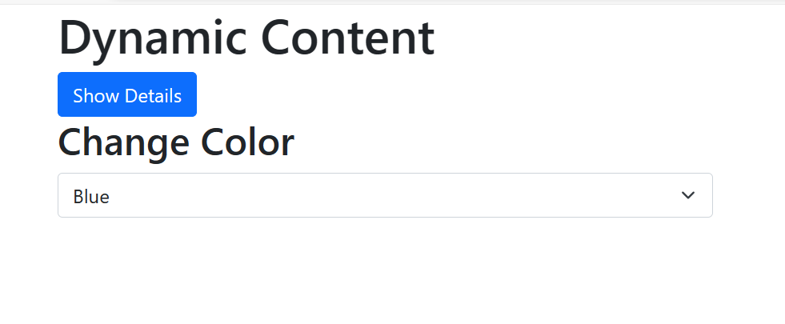

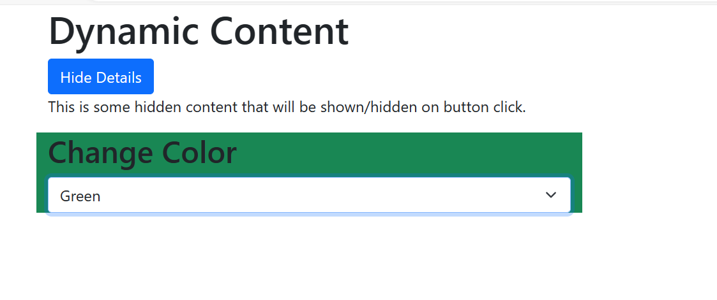

These exercises will help you practice JavaScript fundamentals an